Experiment No. 4

**Procedure :**

Step 1 : Go to jenkins.io

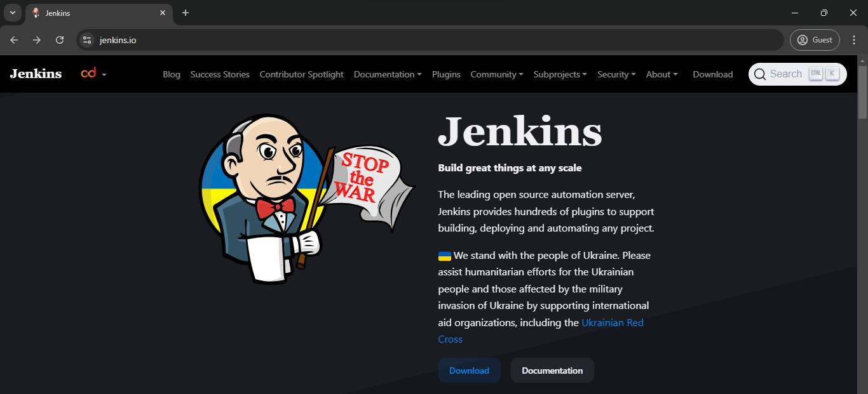

Step 2 : Download Jenkins.

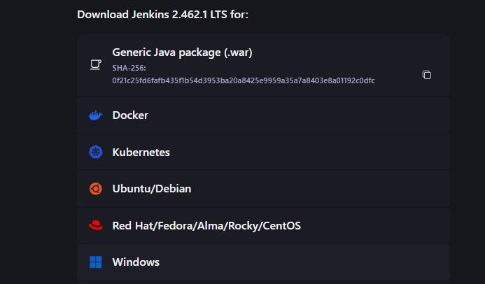

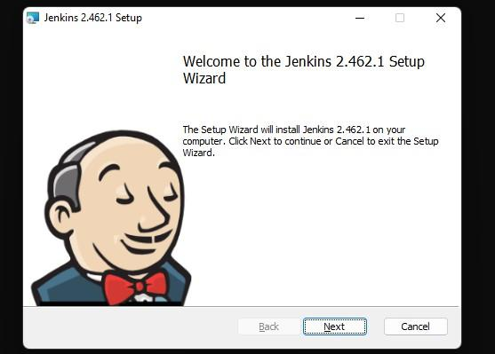

Step 4 : Run service as LocalSystem.



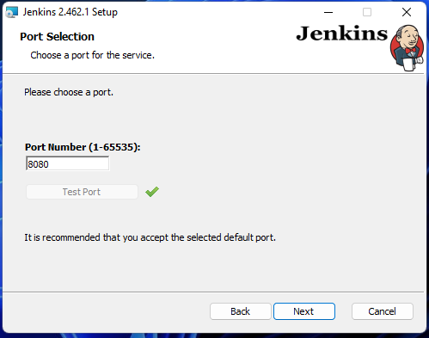

Step 6 : Set JDK path.

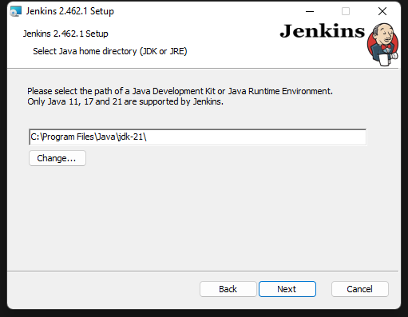

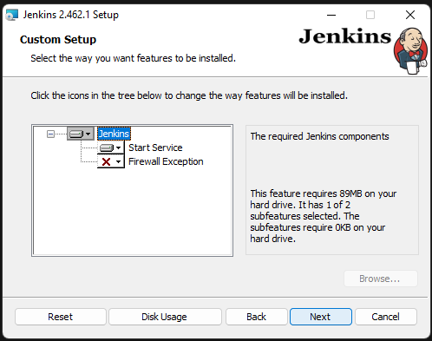

Step 8 : Jenkins setup is completed.

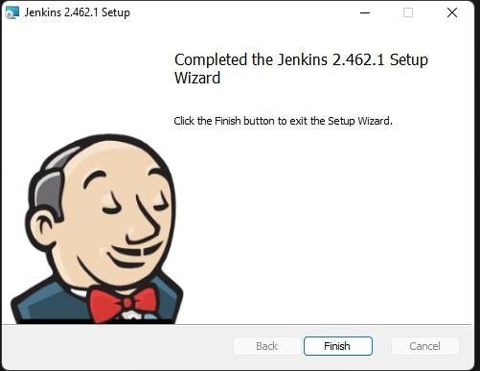

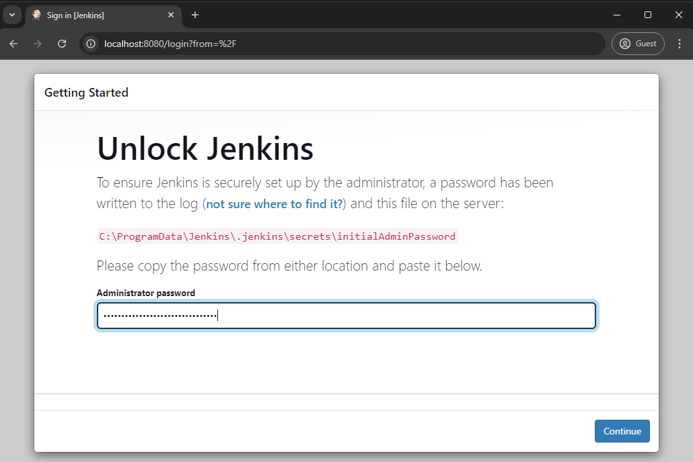

Step 10 : Install suggested plugins.

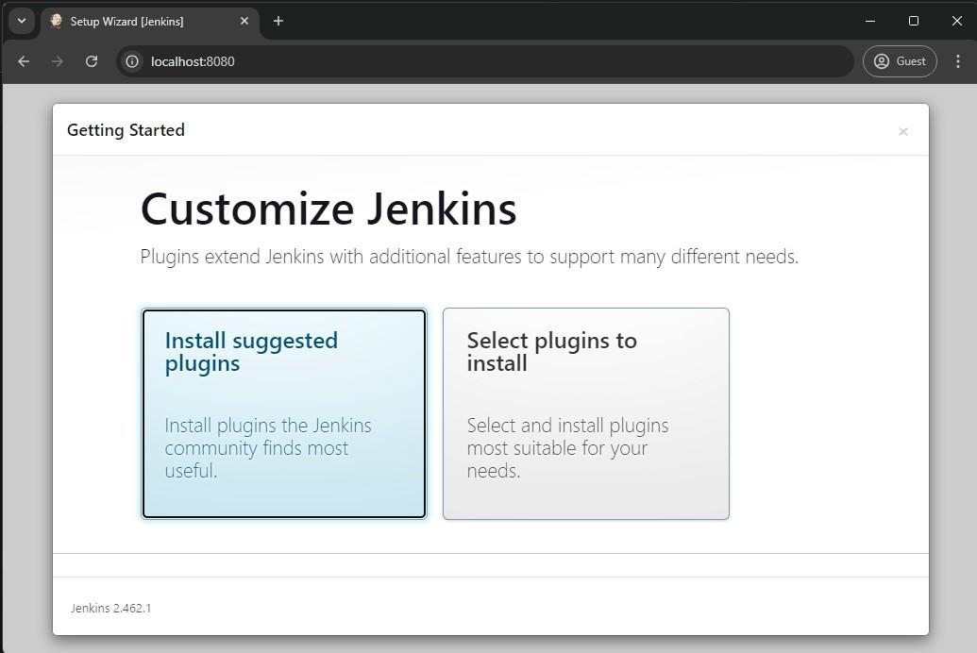



Step 12 : Configure instance.





Step 14 : Download Maven.



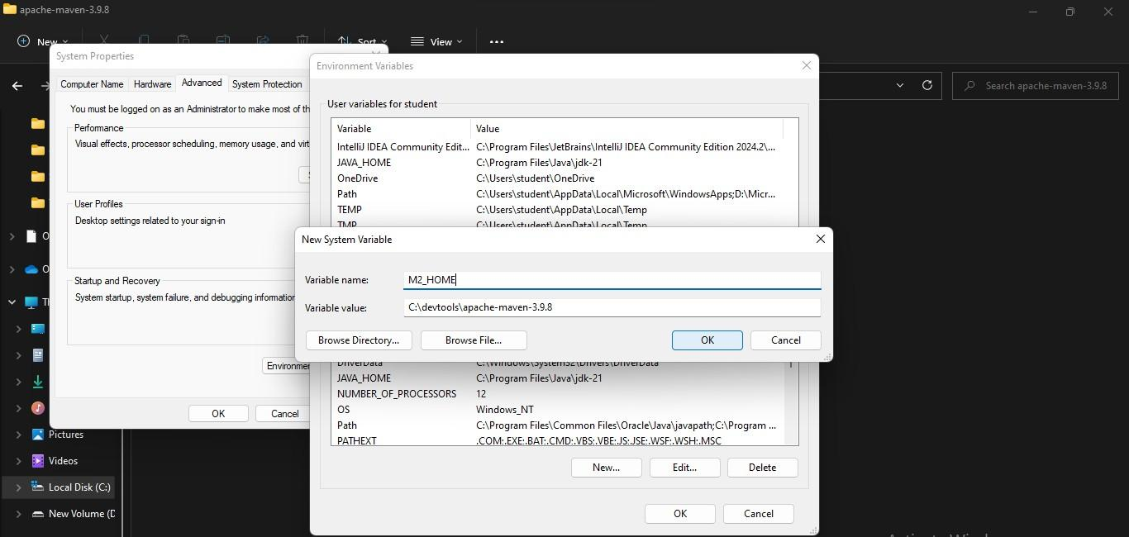

Step 16 : Jenkins dashboard.

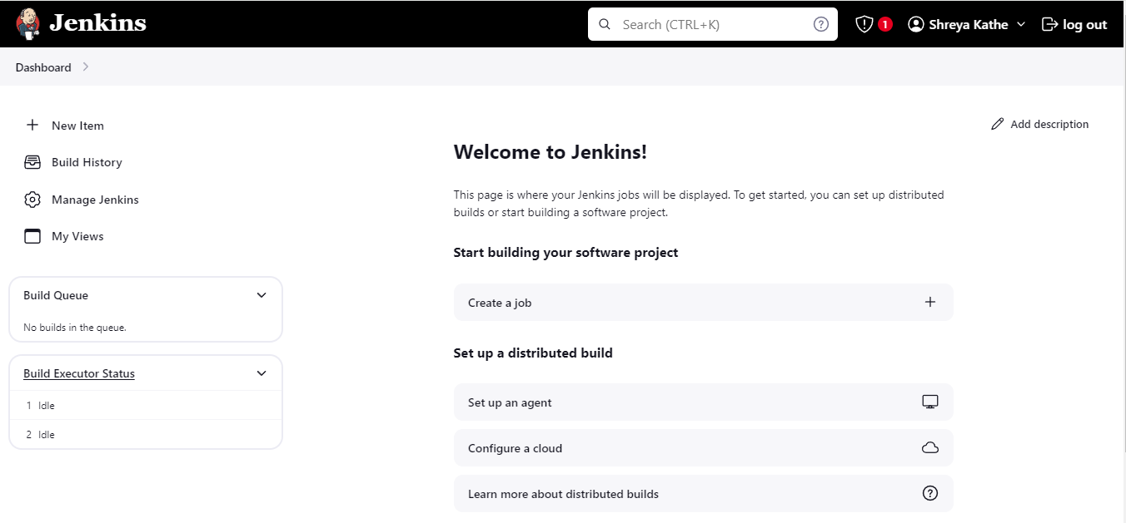



Step 18 : Configure Maven path in Jenkins



Step 20 : In project configuration, add a GitHub repository.





Step 22 : Set up pre-steps.





Step 24 : Finally project build is successful.

